**DAY3 LAB:**

**1.Write a C program to implement Stack operations using array such as PUSH, POP and PEEK.**

#include <stdio.h>

#include <stdlib.h>

#define MAX_SIZE 100

int stack[MAX_SIZE];

int top = -1;

void push(int value) {

if (top == MAX_SIZE - 1) {

printf("Stack Overflow\n");

return;

}

stack[++top] = value;

printf("%d pushed to stack\n", value);

}

void pop() {

if (top == -1) {

printf("Stack Underflow\n");

return;

}

printf("%d popped from stack\n", stack[top--]);

}

int peek() {

if (top == -1) {

printf("Stack is empty\n");

return -1;

}

return stack[top];

}

int main() {

push(10);

push(20);

push(30);

printf("Top element: %d\n", peek());

pop();

pop();

pop();

pop();

return 0;

}

**Output:**

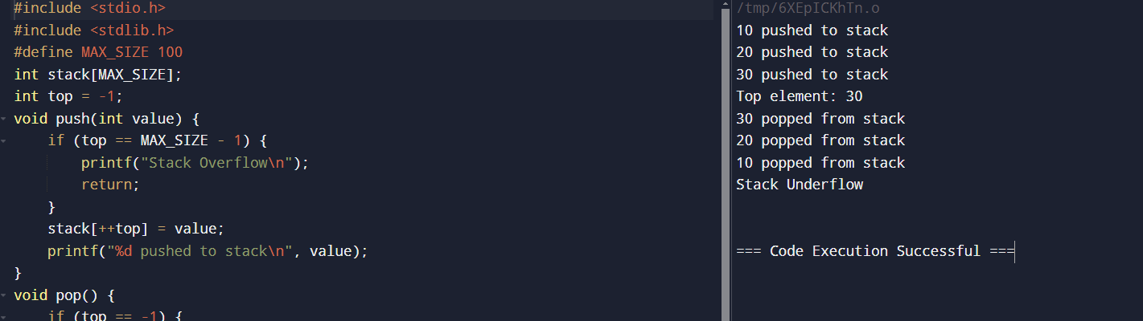

**2.Write a C program to implement Stack operations using linked list such as PUSH, POP and PEEK.**

#include <stdio.h>

#include <stdlib.h>

struct Node {

int data;

struct Node* next;

};

struct Node* top = NULL;

void push(int value) {

struct Node* newNode = (struct Node*)malloc(sizeof(struct Node));

newNode->data = value;

newNode->next = top;

top = newNode;

printf("%d pushed to the stack.\n", value);

}

void pop() {

if (top == NULL) {

printf("Stack is empty.\n");

return;

}

struct Node* temp = top;

top = top->next;

printf("%d popped from the stack.\n", temp->data);

free(temp);

}

int peek() {

if (top == NULL) {

printf("Stack is empty.\n");

return -1;

}

return top->data;

}

int main() {

push(10);

push(20);

push(30);

printf("Top element: %d\n", peek());

pop();

pop();

pop();

printf("Top element: %d\n", peek());

return 0;

}

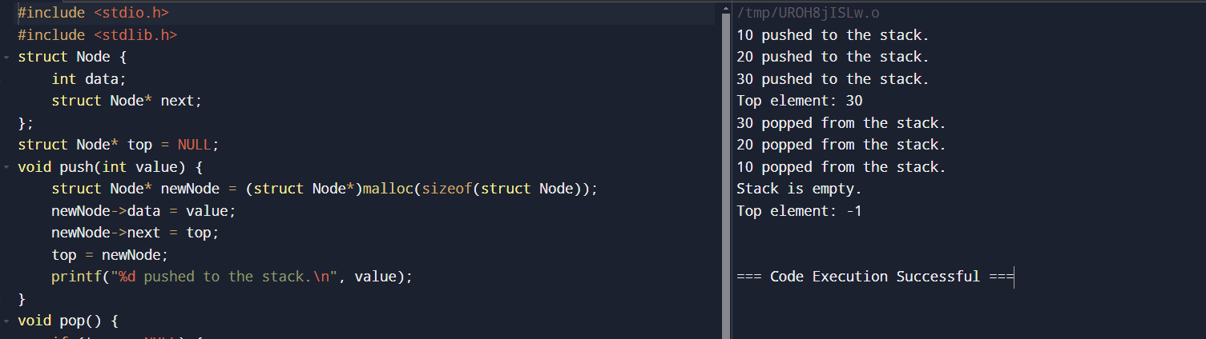

**3.Write a C program for Sorting elements using a stack (e.g., sorting a stack using recursion).**

#include <stdio.h>

#include <stdlib.h>

#include <limits.h>

struct Stack {

int data;

struct Stack* next;

};

struct Stack* createStack() {

return NULL;

}

int isEmpty(struct Stack* root) {

return !root;

}

void push(struct Stack** root, int data) {

struct Stack* newNode = (struct Stack*)malloc(sizeof(struct Stack));

newNode->data = data;

newNode->next = *root;

*root = newNode;

}

int pop(struct Stack** root) {

if (isEmpty(*root))

return INT_MIN;

struct Stack* temp = *root;

*root = (*root)->next;

int popped = temp->data;

free(temp);

return popped;

}

void sortedInsert(struct Stack** root, int data) {

if (isEmpty(*root) || data > (*root)->data) {

push(root, data);

return;

}

int temp = pop(root);

sortedInsert(root, data);

push(root, temp);

}

void sortStack(struct Stack** root) {

if (!isEmpty(*root)) {

int temp = pop(root);

sortStack(root);

sortedInsert(root, temp);

}

}

void printStack(struct Stack* root) {

while (root != NULL) {

printf("%d ", root->data);

root = root->next;

}

}

int main() {

struct Stack* root = createStack();

push(&root, 30);

push(&root, -5);

push(&root, 18);

push(&root, 14);

push(&root, -3);

printf("Stack elements before sorting: ");

printStack(root);

sortStack(&root);

printf("\nStack elements after sorting: ");

printStack(root);

return 0;

}

**Output:**

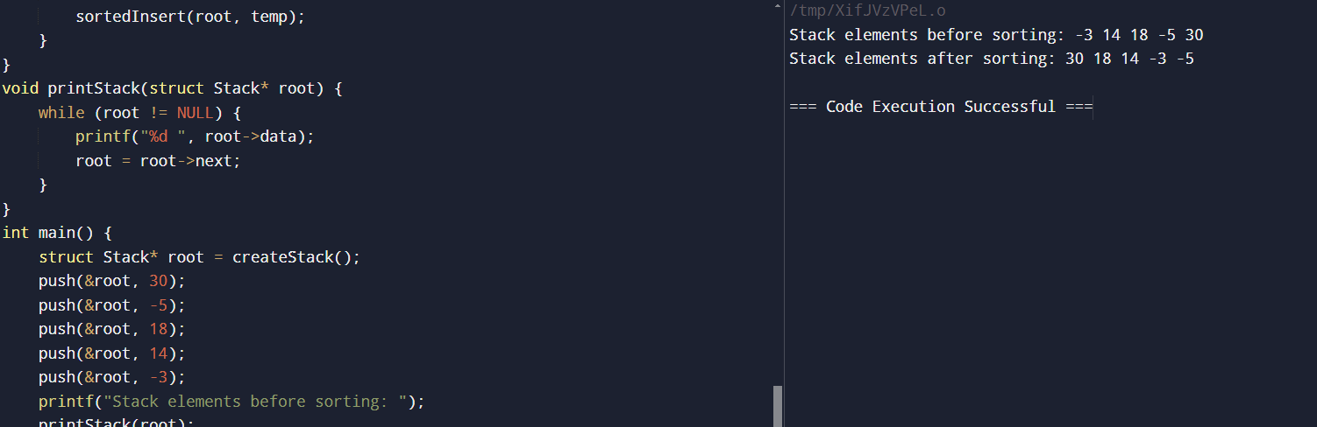

**4.Write a C Program to Simulate Recursive Function Calls Using a Stack**

#include <stdio.h>

#define MAX_SIZE 100

int stack[MAX_SIZE];

int top = -1;

void push(int item) {

if (top >= MAX_SIZE - 1) {

printf("Stack Overflow\n");

return;

}

stack[++top] = item;

}

int pop() {

if (top < 0) {

printf("Stack Underflow\n");

return -1;

}

return stack[top--];

}

int isEmpty() {

return top == -1;

}

void simulateRecursive(int n) {

push(n);

while (!isEmpty()) {

int current = pop();

if (current > 0) {

printf("%d ", current);

push(current - 1);

push(current - 1);

}

}

}

int main() {

int n = 3;

simulateRecursive(n);

return 0;

}

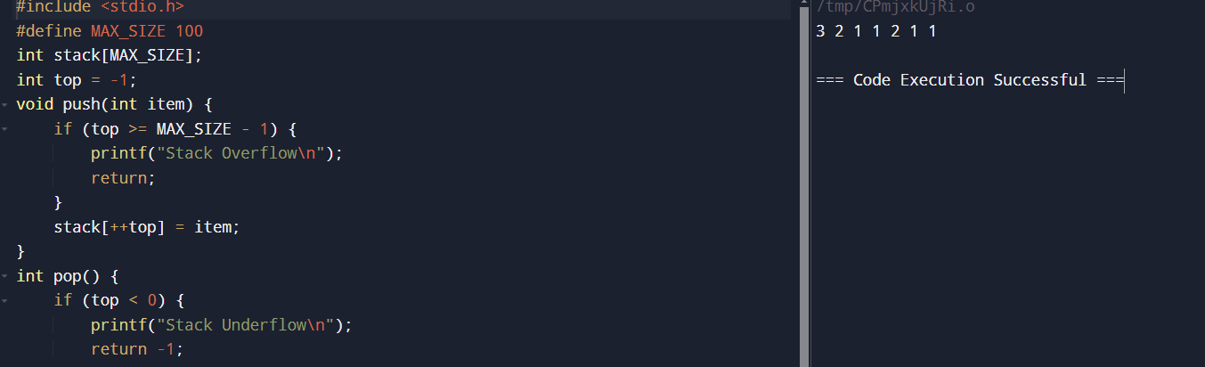

**5.Write a C program to Implement undo and redo functionality using two stacks.**

#include <stdio.h>

#include <stdlib.h>

#define MAX_SIZE 100

int undoStack[MAX_SIZE];

int redoStack[MAX_SIZE];

int undoTop = -1;

int redoTop = -1;

void pushUndo(int item) {

if (undoTop == MAX_SIZE - 1) {

printf("Undo Stack Overflow\n");

} else {

undoStack[++undoTop] = item;

}

}

void pushRedo(int item) {

if (redoTop == MAX_SIZE - 1) {

printf("Redo Stack Overflow\n");

} else {

redoStack[++redoTop] = item;

}

}

int popUndo() {

if (undoTop == -1) {

printf("Undo Stack Underflow\n");

return -1;

} else {

return undoStack[undoTop--];

}

}

int popRedo() {

if (redoTop == -1) {

printf("Redo Stack Underflow\n");

return -1;

} else {

return redoStack[redoTop--];

}

}

void undo() {

int item = popUndo();

if (item != -1) {

pushRedo(item);

printf("Undo: %d\n", item);

}

}

void redo() {

int item = popRedo();

if (item != -1) {

pushUndo(item);

printf("Redo: %d\n", item);

}

}

int main() {

pushUndo(1);

pushUndo(2);

pushUndo(3);

undo();

undo();

redo();

redo();

return 0;

}

**Output:**

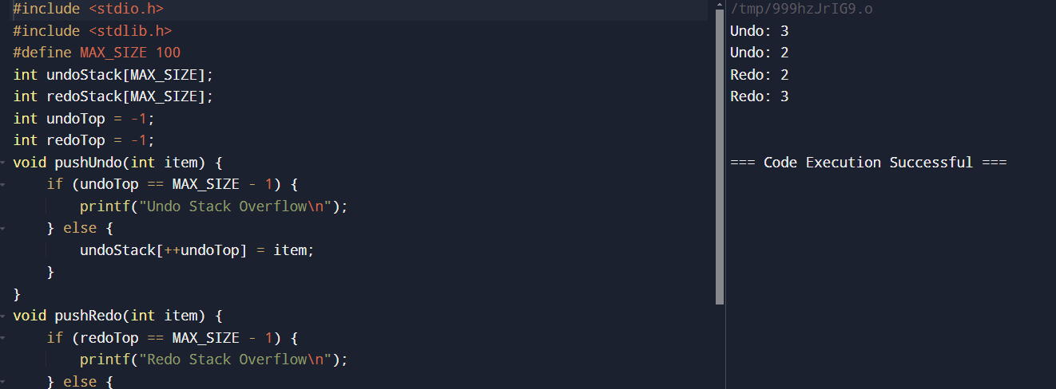

**6.Write a C program to Check if a string is a palindrome using a stack.**

#include <stdio.h>

#include <string.h>

#include <stdlib.h>

#define MAX 100

struct Stack {

int top;

char array[MAX];

};

struct Stack* createStack() {

struct Stack* stack = (struct Stack*)malloc(sizeof(struct Stack));

stack->top = -1;

return stack;

}

int isEmpty(struct Stack* stack) {

return stack->top == -1;

}

void push(struct Stack* stack, char item) {

stack->array[++stack->top] = item;

}

char pop(struct Stack* stack) {

if (!isEmpty(stack))

return stack->array[stack->top--];

return '$';

}

int isPalindrome(char str[]) {

int length = strlen(str);

struct Stack* stack = createStack();

int i, mid = length / 2;

for (i = 0; i < mid; i++) {

push(stack, str[i]);

}

if (length % 2 != 0) {

i++;

}

while (str[i] != '\0') {

char ele = pop(stack);

if (ele != str[i])

return 0;

i++;

}

return 1;

}

int main() {

char str[MAX];

printf("Enter a string: ");

scanf("%s", str);

if (isPalindrome(str))

printf("%s is a palindrome.\n");

else

printf("%s is not a palindrome.\n");

return 0;

}

**Output:**

